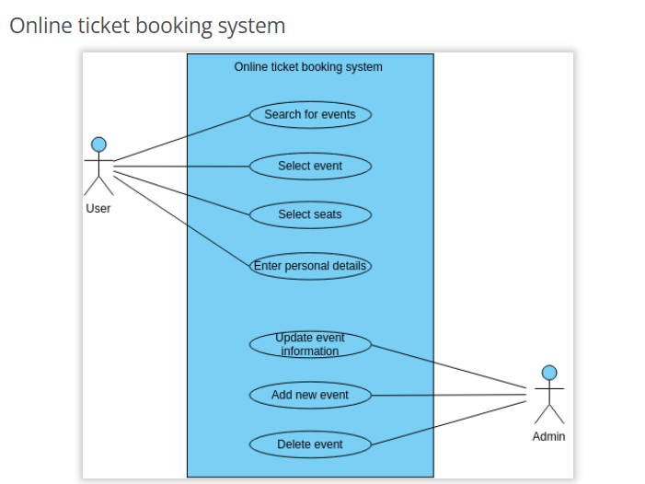

The Online Ticket Booking System use case diagram provides a clear overview of the key functionalities and interactions involved in an online ticket booking platform. The diagram illustrates the actions performed by the User, including searching for events, selecting specific events, choosing seats, entering personal details, updating event information, adding new events, and deleting events.
The use case diagram showcases the user's journey through the ticket booking process. It begins with the User searching for events, allowing them to explore and discover various available options. Once the desired event is found, the User can select it, indicating their intention to attend. The User then proceeds to select seats, choosing their preferred seating arrangement or location within the venue.
To complete the booking process, the User is prompted to enter personal details required for ticket verification and communication purposes. The system provides a seamless interface for the User to input their information securely. Additionally, the diagram highlights the functionality for the User to update event information, allowing them to stay informed about any changes or updates related to the selected event.
Furthermore, the diagram includes additional actions pertaining to event management. The User has the capability to add new events to the platform, enabling event organizers to showcase their offerings. Additionally, the User has the option to delete events, providing flexibility in removing outdated or canceled events from the system.
This template has been thoughtfully designed using Visual Paradigm Online, an intuitive and powerful diagramming tool. Visual Paradigm Online offers a variety of features and capabilities to create professional-grade diagrams, making it an ideal choice for designing and visualizing complex systems like an Online Ticket Booking System.
2. Video Conferencing System
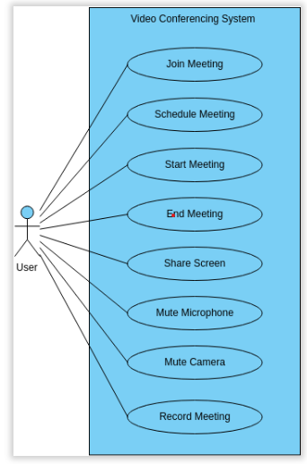
A Video Conferencing System use case diagram is a visual representation of the various features and actions that can be performed within the system. The diagram typically consists of actors, use cases, and relationships between them. In this particular diagram, the main use cases are Join Meeting, Schedule Meeting, Start Meeting, End Meeting, Share Screen, Mute Camera, and Record Meeting.
The Join Meeting use case allows users to connect to an ongoing meeting or join a scheduled meeting. This is an essential feature for remote teams and individuals who need to collaborate and communicate effectively. With this use case, users can easily connect to a meeting and engage in productive discussions with colleagues or clients.
The Schedule Meeting use case allows users to set up meetings in advance and invite participants. This is a great way to ensure that everyone is on the same page and that meetings are organized and efficient. Users can set the date and time of the meeting, invite participants, and set the agenda for the meeting. This use case is particularly useful for teams that work remotely or in different time zones.
The Start Meeting use case allows users to initiate a meeting and invite participants to join. This is an important feature for teams that need to collaborate in real-time and discuss imp ortant topics. Once the meeting has started, users can share their screen or mute their camera if needed. This use case allows for a more personalized and productive meeting experience.
The End Meeting use case allows users to wrap up the meeting and ensure that everyone is on the same page. Once the meeting has ended, users can choose to record the meeting for future reference. This use case is particularly useful for teams that need to review the content of the meeting or share it with others who were unable to attend.

Overall, the Video Conferencing System use case diagram provides a clear and concise overview of the various features and actions that can be performed within the system. By understand ding these use cases, us ers can make the most of the system and collaborate and communicate effectively with colleagues and clients. The diagram can also be helpful for identifying areas for improvement and optimizing the video conferencing experience for all users.

Pros of creating this diagram
There are several benefits to creating a use case diagram for a Video Conferencing System, such as the one you described. Here are some of the potential pros:
- Improved understanding: A use case diagram provides a visual representation of the system and its features, making it easier for stakeholders to understand how the system works and what it can do. This can be especially helpful for people who are new to the system or who need a quick reference guide.
- Improved communication: The diagram can be used to facilitate communication between different stakeholders, such as developers, designers, and business analysts. By providing a common language and understanding of the system, the diagram can help to ensure that everyone is on the same page and working towards the same goals.
- Identifying gaps and redundancies: When creating a use case diagram, it's important to examine the system holistically and identify any gaps or redundancies in the features. This can help to improve the system by ensuring that it meets the needs of its users, is efficient, an d is easy to use.
- Planning for future development: A use case diagram can also be used to plan for future development of the system. By identifying the most important features and use cases, stakeholders can prioritize what needs to be developed next and ensure that the system continues to evolve to meet the changing needs of its users.
3.Ride-sharing service:
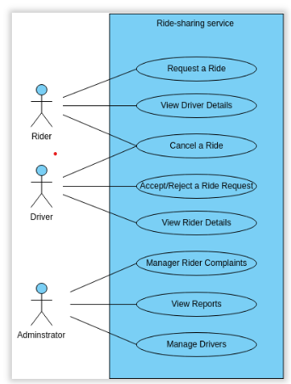
A Ride-sharing Service is a software application designed to allow users to book rides with drivers who use their own personal vehicles to transport passengers. The system typically includes features such as ride request management, driver management, and payment processing. The use case diagram outlines the various tasks that can be performed within the system.
The Request a Ride use case allows users to request a ride from a driver using the ride-sharing service. This typically involves providing information such as the pickup and drop-off locations, the number of passengers, and the desired pickup time. Once a driver accepts the ride request, the user can view the driver details using the View Driver Details use case.
The Cancel a Ride use case allows users to cancel a ride that has been previously requested. This can be done for various reasons such as changes in plans or unexpected circumstances. The system can process the cancellation and notify the driver of the cancellation.
The Manage Rider Complaints use case enables the ride-sharing service to manage any complaints or issues raised by riders. This can include issues such as driver behavior, payment disputes, or other concerns. The system can investigate the complaint and take appropriate action, such as suspending the driver's account or issuing a refund to the rider.
The View Reports use case allows the ride-sharing service administrators to view various reports related to the system's performance. This can include reports on ride volume, driver performance, and revenue. The Manage Drivers use case enables the ride-sharing service to manage its drivers, including adding or removing drivers, updating driver information, and managing driver permissions.

Pros of creating this diagram
Creating a use case diagram for a Ride-sharing Service can provide several benefits. First, it can help to identify any gaps or areas of improvement in the system's functionality and ensure that all necessary use cases have been accounted for. This can help to avoid potential issues or errors that could arise during the system's implementation and use.
By mapping out the various use cases, stakeholders can gain a better understanding of how the system works and how it can be leveraged to improve ride-sharing processes.
Second, the use case diagram can serve as a valuable communication tool between stakeholders, including ride-sharing service managers, developers, drivers, and riders. It can help ensure that everyone involved in the system's development and implementation is on the same page and has a shared understanding of the system's purpose and functionality. This can help prevent misunderstandings and ensure that the system meets the organization's needs and expectations.
Third, the use case diagram can help to improve collaboration between stakeholders, which can lead to a more successful implementation and adoption of the system. By identifying potential gaps or issues in the system's functionality early on, stakeholders can make necessary adjustments to the system, ultimately leading to a more efficient and effective system development process. Additionally, the use case diagram can help to facilitate communication and collaboration between stakeholders, improving the chances of a successful implementation and adoption of the system.
4.E-commerce website:
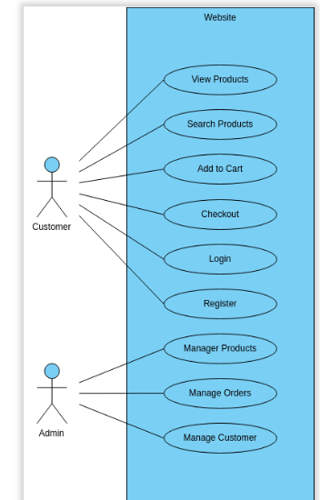
The E-commerce website is an essential platform for online shopping, providing a range of features that enable customers to browse, purchase,
and manage products. The website provides a user-friendly interface that makes it easy for customers to find what they are looking for and complete transactions quickly and securely.
One of the primary features of the website is the ability to view products. This feature allows customers to browse a wide range of products, including clothing, electronics, and household items. Additionally, the website provides a search function that enables customers to find specific products according to their preferences.
The website also offers the ability to add products to a cart and checkout. Customers can add products to their cart and complete transactions securely using various payment methods, such as credit cards, PayPal, and others. This feature ensures that customers can complete transactions quickly and conveniently, without the need to visit a physical store.
Another essential feature of the website is the ability to manage products, orders, and customers. Website administrators can manage product information, such as prices, descriptions, and images, ensuring that customers receive up-to-date and accurate information. Additionally, administrators can manage orders and customers, providing support for customers who have questions or issues with their orders.

5.Online Banking System:
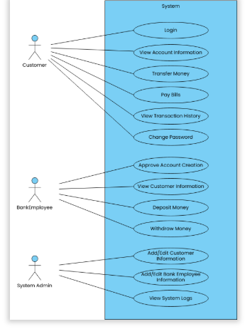

Online Banking System
An Online Banking System is a software application that enables users to perform various banking activities online. The system offers several features and functionalities including logging in, viewing account information, transferring money, paying bills, viewing transaction history, approving account creation, depositing money, withdrawing money, adding/editing customer information, and viewing system logs.
The Login use case allows users to log in to their account securely using their username and password. The system validates the user's credentials and grants access to their account.
The Transfer Money use case allows users to transfer money from their account to another account using a secure and efficient process. The user selects the recipient's account, enters the amount to transfer, and confirms the transaction.
The View Account Information use case allows users to view their account information, such as balance, account number, and transaction history. The system displays the information in an organized and easy-to-read format, allowing users to track their account activity and make informed decisions.
The Pay Bills use case allows users to pay their bills online conveniently and securely. The user selects the biller, enters the payment amount, and confirms the payment. The system sends a confirmation email to the user and updates the account balances.

